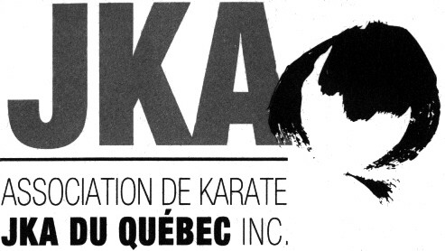 | Winter Camp  25 et 26 February 2023
Sensei Jean-Pierre Cusson, 7th Dan
Sensei Louis-A. Dessaint, 7th Dan
Sensei Manon Quirion, 6th Dan

Participation Form

Last Name : |  |  |  |  | First Name :
Rank : |  |  |  |  | Dojo :

Winter Camp for Green to Black Belts
Please tick the chosen trainings and the associated fee
25 February, Saturday - Tranings  ___11h00 à 12h30 Green to black belts  ___14h00 à 15h30 Green to black belts | 26 February, Sunday - Trainings  ___11h00 à 12h30 Green to black belts  ___14h00 à 15h00 Brown and black belts

$ 80 4 trainings
$ 60 3 trainings
$ 45 2 trainings
$ 25 1 training.
For on-site registrations You will have to pay in cash and make sure you have the exact amount.
Note to instructors You have until February 20 to send us your registrations and your check.

DAN AND QUALIFICATION EXAMS
Note to instructors You have until February 23 to send us the registrations for the Dan and qualification exams and your check to Jean-Pierre Cusson. Cash payments must be made on the first day of Camp. Please note that only JKA members in good standing, registered for camp and with a valid JKA passport and JKA card will be eligible for the Dan and qualification exams.

Dan Exam Fee | Qualification Exams Fees (registration fee included)
$ 280 CAD Shodan | $ 140 CAD Judge – Level D
$ 340 CAD Nidan | $ 140 CAD Instructor – Level D
$ 380 CAD Sandan | $ 200 CAD Examiner – Level D

N.B.: The karatekas who will take an exam must submit their JKA passport at the start of the camp and their Dan Exam Record form if applicable.

Eligibility criteria for qualifications exams
Prerequisites for Instructor D: Nidan and 20 years old or more.
Prerequisites for Judge D: Nidan and Instructor D.
Prerequisites for Examiner D: Sandan for at least 3 months, Instructor D, Judge D and 25 years old or more.
** It is possible to take more than one Level D qualifying exam on the same day.

For more information, please contact Jean-Pierre Cusson at (450) 441-1061 or by email karate.jka@videotron.ca.
-----------------------------------------------------------------------
Rules regarding the use of cameras, videos, cellulars, etc. during AKJKAQ activities.
It is strictly forbidden to photograph, film or take pictures with any device without permission from AKJKAQ.
For more information, please contact Jean-Pierre Cusson by email karate.jka@videotron.ca.

